

|  |  |  |  |  |
| --- | --- | --- | --- | --- |
| 7800 York Rd, Towson, MD, 21252 |  |  |  |  |

#JuanSolutions LCMS

Greg Friedman, Mark Holson, Brennan Mcpherson, Howard Wheeler

Table of Contents

1. LCMS At A Glance 3

Overview

Features

1. Getting Started 2

Logging In

Home Screen

View Your Log

View Your Settings

Taking a Lesson

Signing Out

1. Manager Use 2

Logging In

Home Screen

View Your Employees

Add a New Employee

Edit an Employee

View an Employee's Report

View an Employee's Log

View Your Lessons

Add a New Lesson

Edit a Lesson

View Your Goals

Add a New Goal

Edit a Goal

1. Auditor Use 2

Logging In

Home Screen

View All Employees

View an Employee's Report

View an Employee's Log

# LCMS At a Glance

#JuanSolutions is a small but powerful software development start up company. At the moment we consist of 4 employees. Being such a small business we are able to provide more personal care and customer service that any other bigger corporation is unable to provide.

Our current project is a learning content management system designed for the training of air traffic controller. We have set up our system to allow managers to create goals that employees must train towards (number of aircrafts, speed of aircraft, wind patterns). The employees will be able to choose from this list of goals to create a lesson plan for themselves. The goals that the employee chooses will change different variables within the simulator as to specifically test the skills of the employee. It also is able to change the difficulty of each variable, so as the employee progresses their skills can be put to the test. We believe that this method of learning content management system will have a powerful effect on the way air traffic controllers are trained. By testing individual skills the system will ensure that employees have a strong understanding of every skill.

# Getting Started

1. Logging in

When beginning the software, you are presented with a log in screen as follows. You are able to log in as an employee, manager, or auditor. Depending on which account you have assigned to your username, you will have different permissions.

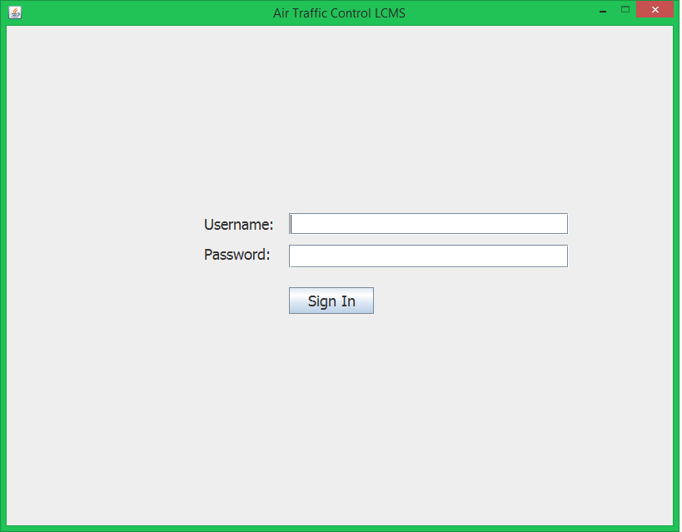

For the purposes of the User Guide we will first log in as an employee. 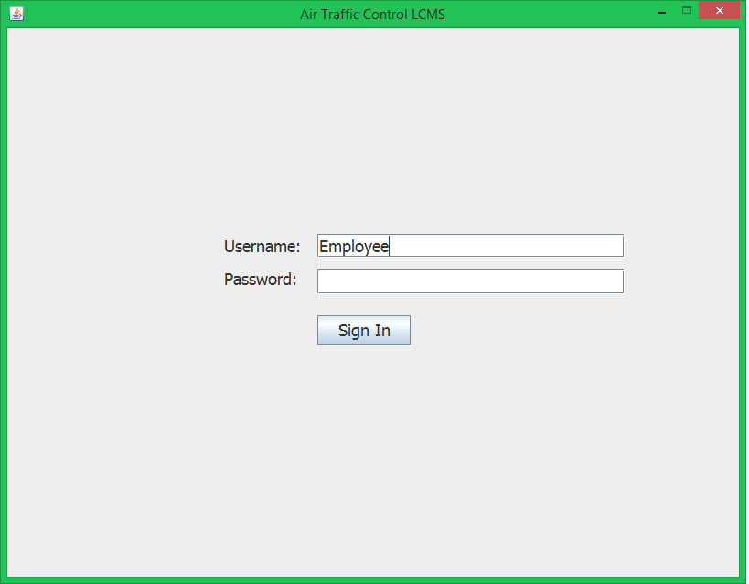

1. Home Screen

Once an employee is logged in then they are presented with their home screen. On the home screen you first see the employee lesson report. In the lesson report it gives a history of all the lessons an employee has taken, their score, and the lesson ID. This provides a quick way for employees to track their progress. Also on this screen is where employees can check their log, take a new lesson, check their user settings, or sign out.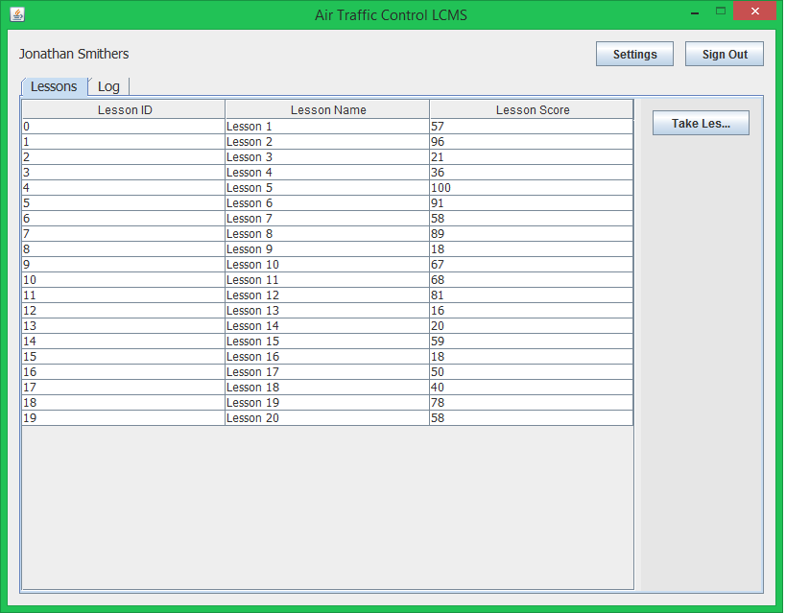

1. Viewing the Log Screen

From the home screen you can also check the employee log. The log keeps track of every action taken by an employee. From signing in, signing out, updating settings, and taking lessons the log tracks it and gives a timestamp of everything. 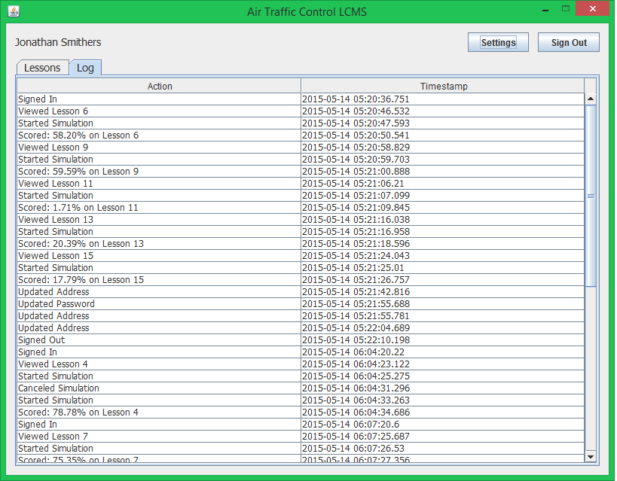

1. Viewing Settings

From the home screen you can also view and edit user settings. Under settings are the employee username, actual name, address, current password, and if they wish to change passwords an area to do so. 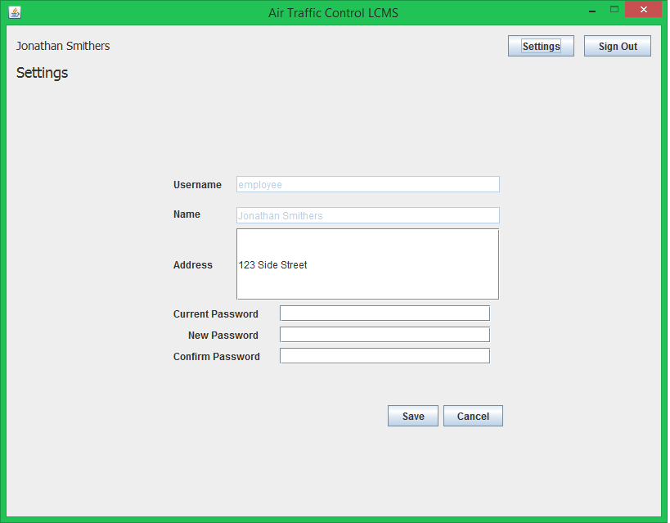

1. Choosing Lesson

As an employee, you are able to choose which lesson to take from the list of possible lessons. Each lesson consists of 3 separate goals. Once the employee choses the correct lesson then the simulator will begin with the changes in variables based upon which lesson was picked.

# Manager Use

1. Logging In

Exactly like the employee the manager will first arrive to the log in screen , where they must type in their username and password.

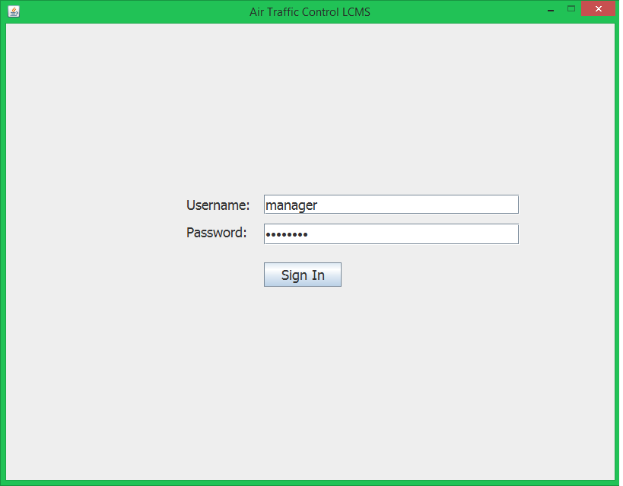

1. Home Screen

The managers home screen consists of tabs for lessons, goals, employees, and buttons to add/edit employees and view log/reports. The employee tab is what shows when the manager first logs in, showing the list of all employees who have an account in the system. The list consists of the employee’s ID, first and last name, and address. From the home screen as well the manager can add an employee if a new trainee begins, edit an employees information, view a specifc employee’s report or log.

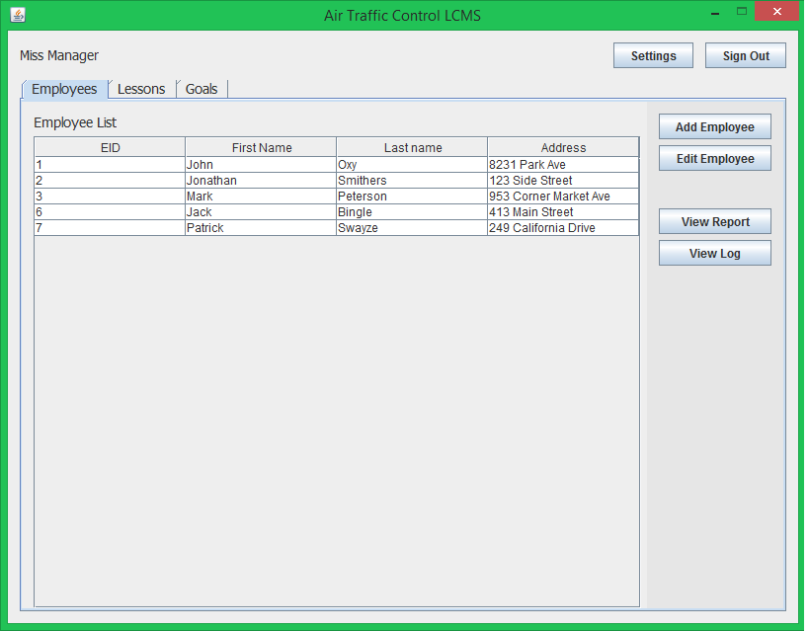

1. Viewing Employee Report

To view an employee’s report, the manager must select the specific employee they wish to view the report for then click the view report button. Once clicked, this page will come up where the manager can see the lesson ID (which specifies which lesson the employee took), their score, and the start/stop time. 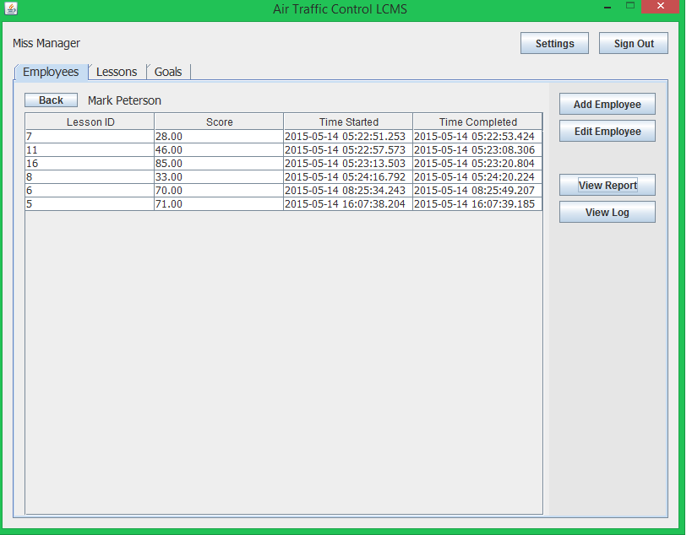

1. View Employee’s Log

Another feature the manager can use is the view log button. Select an employee and click the view log to view the page below. The log records every action taken by the employee and the time stamp. The time is tracked so the manager knows how long the employee spent in the simulator.

1. Add/Edit Employee

When a manager adds an employee they are able to enter the employee username, password, first/last name, and address. After doing this they will be put into the database and able to take lessons.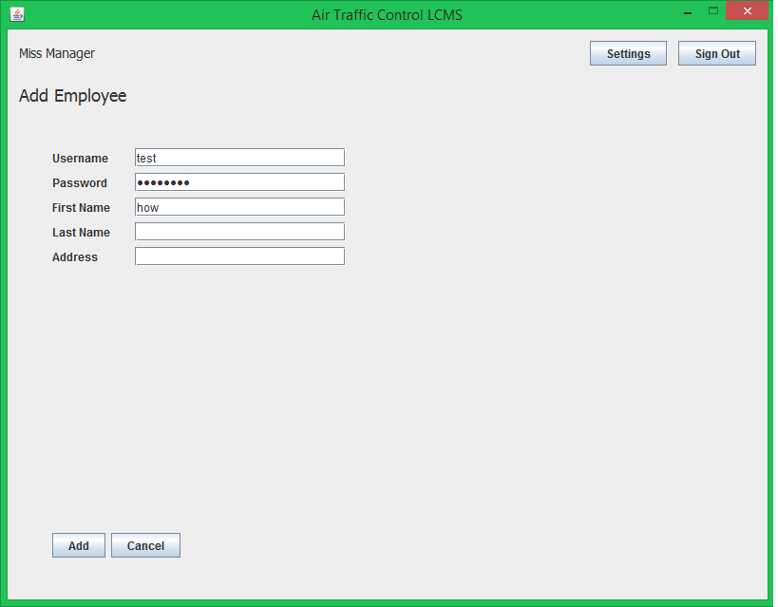

1. Add/Edit Goals

When viewing the list of goals the manager has the option to view the goals, add a goal, or edit an existing goal.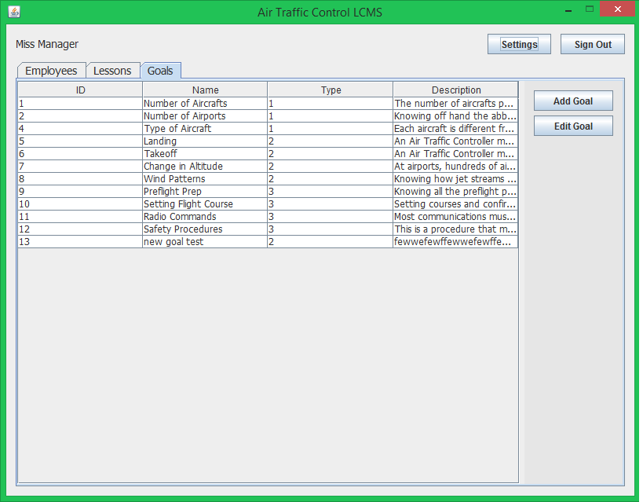

As the manager, they have the permission to add or edit new goals for different lesson plans. When adding/editing the goals the manager has the ability to give the goal a name, specify which type of goal it is, what simulator variable it corresponds to, entering the value (changes the difficulty of the variable), give a breif description, and a full text explaination of what the goal is and how it will help in the training. The manager can use this screen to add a new goal or edit the information on already existing goals.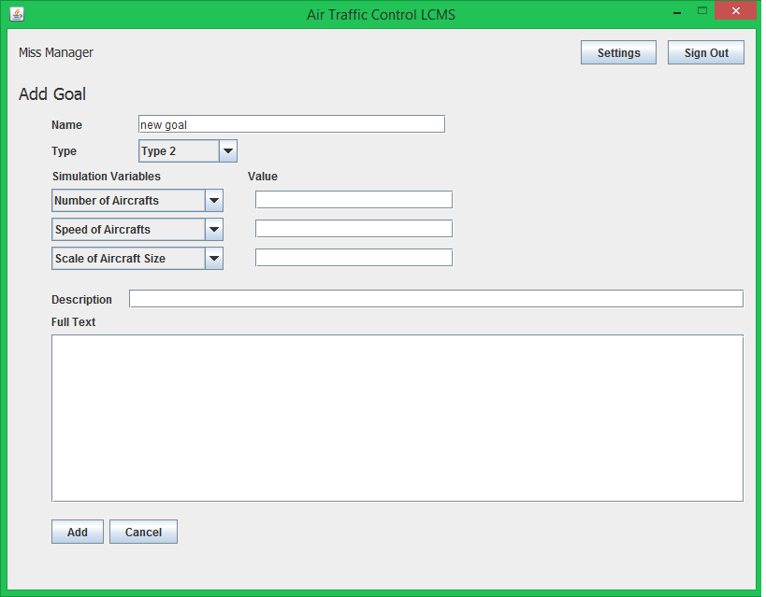

1. Add/Edit Lessons

When viewing the list of lessons the manager has the option to view the lessons, add a lesson, or edit an existing lesson.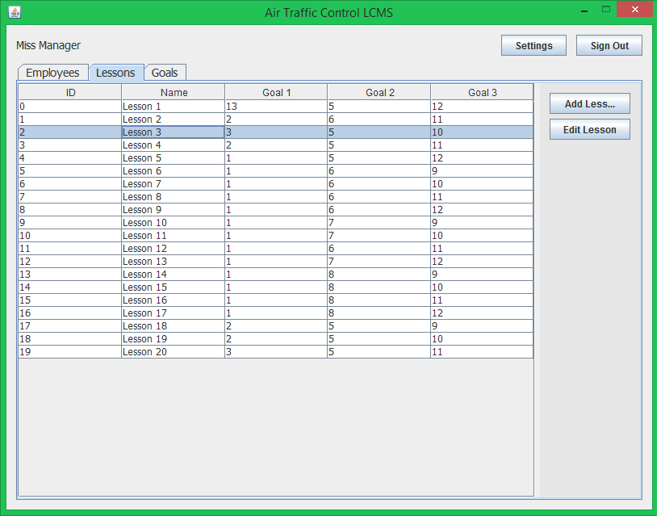

On the add/edit lesson page, the manager has the abillity to give a lesson a name, choose the 3 goals the lesson will consist of, and get a preview of what the lesson will be. When editing the manager can change the chosen goals or the name.

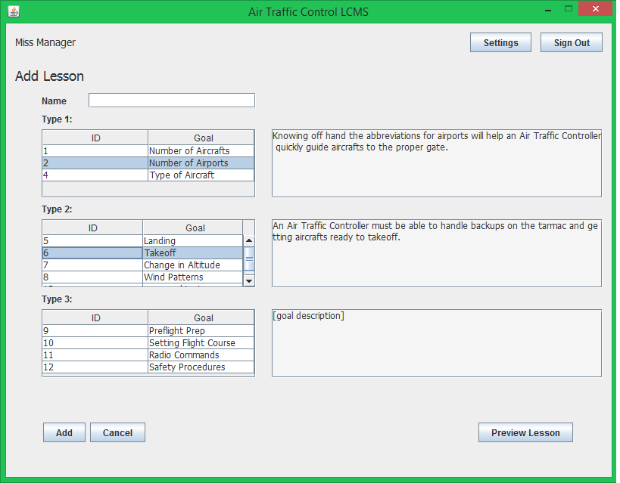

When previewing the lesson, the descriptions of each chosen goal are combined to give a quick lesson plan 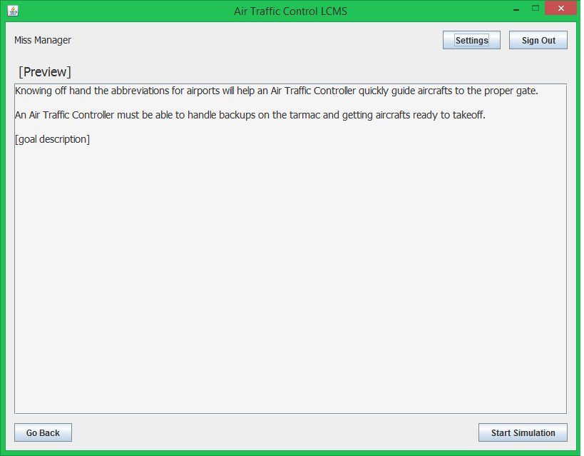

# Auditor Use

1. Logging in

Exactly like the other users the auditor will first arrive to the log in screen , where they must type in their username and password.

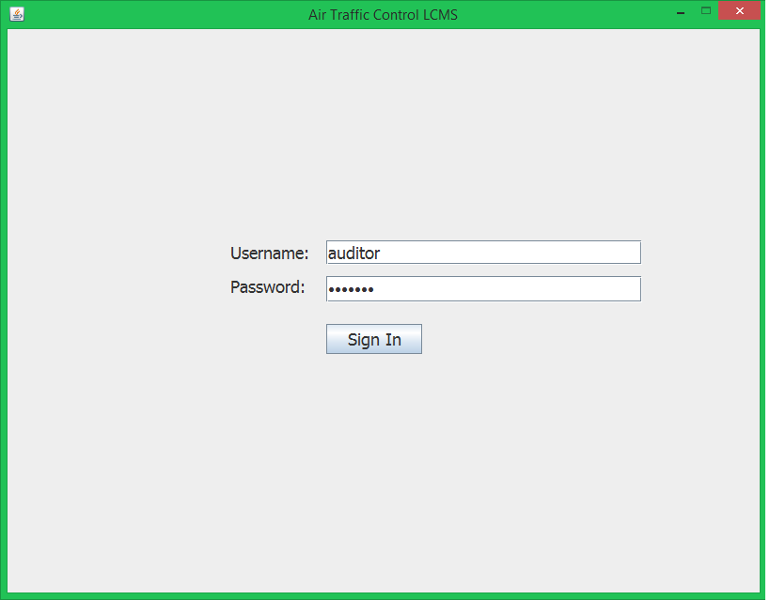

1. Home Screen

On the auditor’s home page they have less permissions than the other users. They are able to view all employee’s, view employee reports, and view employee logs.

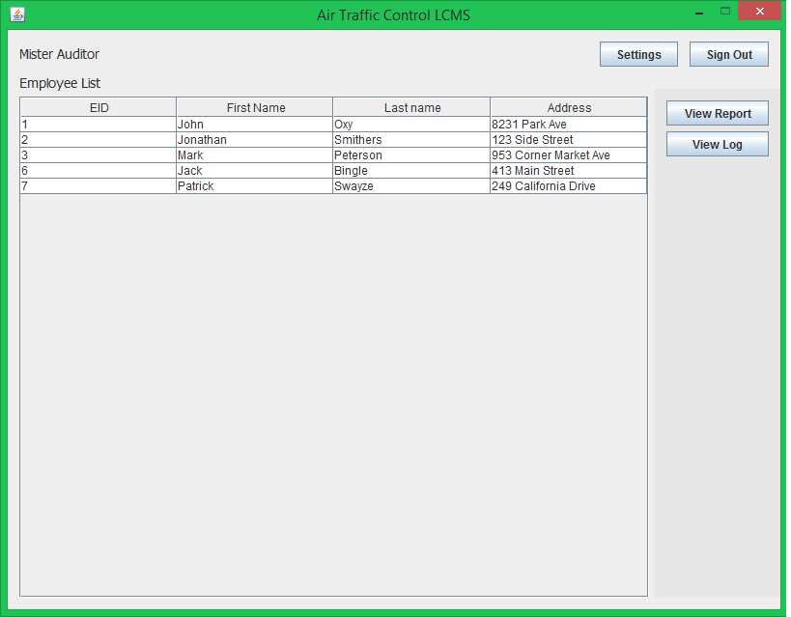

1. Viewing Employee Report

To view an employee’s report, the manager must select the specific employee they wish to view the report for then click the view report button. Once clicked, this page will come up where the manager can see the lesson ID (which specifies which lesson the employee took), their score, and the start/stop time. 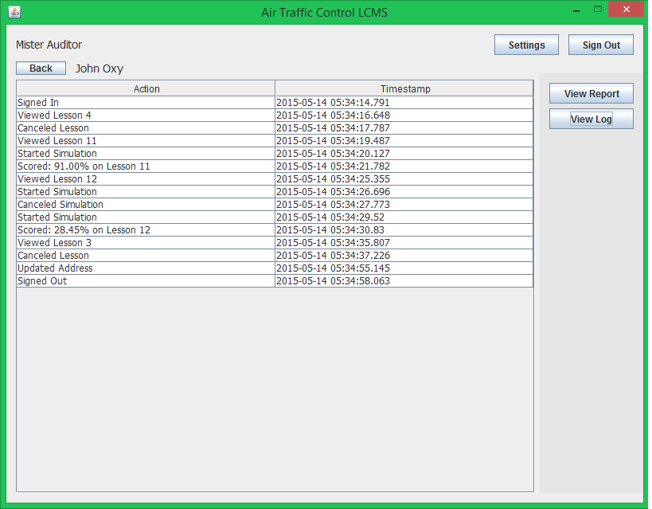

1. View Employee’s Log

Another feature the manager can use is the view log button. Select an employee and click the view log to view the page below. The log records every action taken by the employee and the time stamp. The time is tracked so the manager knows how long the employee spent in the simulator.

